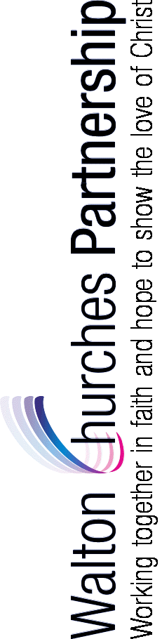
From: Rev. Matt Trendall, Walton Churches Partnership (WCP)
Email: matt.trendall.mk@gmail.com Phone: 01908 582839
Address: Wavendon Rectory, Walton Rd, Wavendon, Milton Keynes MK17 8LW

Details of Wedding
Date | Time | Name and location of Church
Exact name of parish where marriage is to take place
(if unsure, please check this with your Minister)

 | Groom | Bride
Surname:
First Names (All):
Nationality:
Phone number
Email address:
Address:
(including Post Code)
How long (yrs & months) have you lived at this address?

Date you moved in (mth/yr):
If living outside Walton Parish, which is your parish church?
What will be your address after your wedding?
Are you on the Electoral Roll of the church where you are getting married? | Yes / No | Yes / No
IF not on Electoral Roll or currently resident in parish:  What is your “Qualifying Connection” with the church where you are getting married?  (please underline the relevant item for bride and/or groom) | a. Prior residence in parish (self)  b. Parents’ current or prior residence in parish  c. Prior attendance at church (or membership) (self or parents)  d. Baptised/confirmed in parish  e. Parents or grandparents married in parish | a. Prior residence in parish (self)  b. Parents’ current or prior residence in parish  c. Prior attendance at church (or membership) (self or parents)  d. Baptised/confirmed in parish  e. Parents or grandparents married in parish

Please return a signed copy of the form – either scanned via email or posted to the above address.

I hereby certify that, to the best of my belief, the answers to these question are correct:

Signed: (Groom) ........................................................................................... Date: ................................................

Signed: (Bride) ........................................................................................... Date: .................................................

The information given above will be used for the completion of the necessary legal processes prior to the marriage and the registering of the marriage itself.

